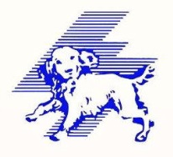
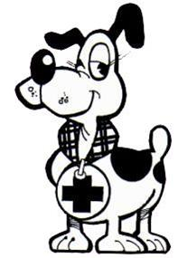
STV and RBS
“Finding Scotland’s Real Heroes”
Hero Animal of the Year Award
“Therapet Ben” has been nominated in the Hero Animal of the Year Award category of the
STV and RBS “Finding Scotland’s Real Heroes”
This will be shown on Friday 29th August
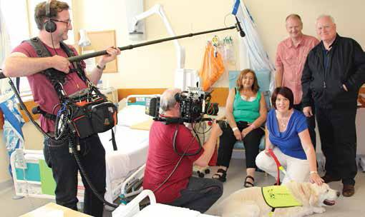
TO VOTE GO TO STV WEB SITE>>> http://shows.stv.tv/real-heroes/voting/
Please remember you have to sign in to (or join) STV before you can cast a vote.
Unless otherwise stated in the programme, lines open at 5pm (17:00) on the day the category is scheduled to feature in that night’s programme and lines close at 12pm (12:00) the following Friday.
Winners will be announced on STV in RBS-Finding Scotland's Real Heroes The Awards on October 14.
TEXT NUMBER WILL BE AVAILABLE ON FRIDAY NIGHT
THIS WILL BE LISTED ON WEB SITE AFTERWARDS

